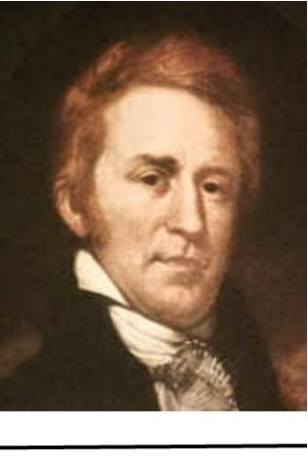
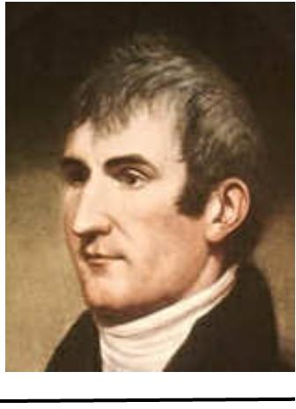

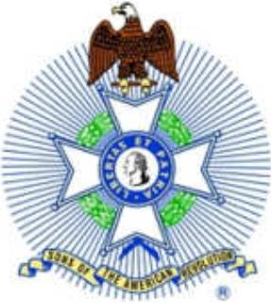 The Journal

Editor: Dave Kingsella
Clackamas, Oregon
dakingsella@msn.com
Volume 22 Issue 1 January - March 2017
The Newsletter of the Lewis and Clark Chapter Oregon Society, Sons of the American Revolution

Editor's Message:

Compatriots, this is my first edition of the newsletter, ‘The Journal’. My goal is to have a newsletter out at least once a quarter initially and more frequently in the future. Newsletters will be emailed to all members with an email address on file. If a member does not have an email address, a copy can be sent US Mail. If you would like a hard copy mailed, please provide the editor with your postal address. Because of cost considerations, these will be black and white versions. The color versions will continue to be emailed, and also available on our website, at www.orlcsar.org. As always, please submit any items for inclusion in future issues to me at dakingsella@msn.com

March Meeting:

march 4 2017 meeting

10:00 – 11:30

Beaverton Resource Center,

12500 SW Allen Blvd.

Beaverton, OR

Local author Lilly Robbins Brock who writes about the living WWII veterans of the area, and author of the book “Wooden Boats Iron Men”. She will be speaking on her work with WWII veterans and showcasing her books.
Hope to see you there

Chapter Activities:

Past Events:

Lewis and Clark Color Guard posted Colors at the ‘Sons and Daughters of Oregon Pioneers’ (SDOP) Annual Meeting

On Saturday, February 11, 2017, Color Guard Compatriots, Grier Ingebretsen, Michael Tieman, and Dave Kingsella provided the Color Guard for the SDOP Annual Meeting at the Monarch Hotel in Clackamas.
We provided a table, displaying items from our Learning Trunk and had an opportunity to meet with several people in their organization and provide information on our Revolutionary War Memorial project and possible made contacts with potential Lewis and Clark Chapter members.
These types of activities are an excellent way to get the word out about our organization and our War Memorial project.

quotes of our forefathers:

"Every government degenerates when trusted to the rulers of the people alone. The people themselves, therefore, are its only safe depositories." – Thomas Jefferson, Notes on the State of Virginia, February 14, 1781.

Revolutionary War History:

King George III declares a permanent ceasefire to the American Revolution

On this day in history, February 4, 1783, King George III declares a permanent ceasefire to the American Revolution. After the surrender of General Charles Cornwallis' army at Yorktown, Virginia in October, 1781, many members of Parliament decided it was time to end the war. The House of Commons first voted to end the war on February 27, 1782 and in March, Prime Minister North resigned.
By April 4, General Henry Clinton was replaced as Commander of British forces in North America by Sir Guy Carleton, who was charged with implementing a withdrawal. Informal peace negotiations began in April in Paris between Ben Franklin and Richard Oswald, the representative of the new Prime Minister, Charles Watson Wentworth, the Marquess of Rockingham.
By September, 1782, John Jay had arrived in Paris from Spain and John Adams had arrived from Holland. They joined the now formal peace negotiations and on November 30, a preliminary peace treaty is signed, in which Britain acknowledges the sovereignty of the United States, the boundaries of the United States are determined and Britain agrees to withdraw its forces from US territory.
The preliminary treaty is ratified by Parliament on January 20, 1783 and a ceasefire is declared by King George on February 4. The American Congress declares a ceasefire on April 11 and ratifies the preliminary treaty on April 15, 1783.
On September 3, 1783, the final Treaty of Paris is signed in Paris by representatives John Jay, John Adams and Ben Franklin from America and representative David Hartley from Great Britain. Congress ratifies the Treaty of Paris on January 14, 1784 and Parliament ratifies it on April 9, 1784. The final act of the road to peace is a formal exchanging of the signed documents in Paris on May 12, 1784, finally bringing the American Revolution to a close.

Our Patriots:

Captain Ithamar Wright, Massachusetts Minuteman

Captain Ithamar Wright, patriot ancestor of Compatriot Dave Kingsella was born 26 October 1734, in Brookfield, Worcester County, Massachusetts. His parents were Obadiah and Harriet (Southwell) Wright. He married Elizabeth Walker February 1756. Elizabeth was a fifth-generation Mayflower descendent of Mayflower passengers William and Susanna White.
Ithamar was Captain of a company of Massachusetts Minutemen that responded to the alarm at Lexington on 19 April 1775. Ithamar was also a member of the Brookfield Committee of Safety in 1775, 1776 and 1777.
Not a lot is known about the rest of Ithamar’s life except that he was from a prosperous farm family, he was active in his community and his church, and that he had two sons, Simeon and Obadiah; and one daughter, Rosetta. His son, Simeon was also a revolutionary war soldier, serving as a private in the Massachusetts Militia.
Ithamar died in February 1802 in Brookfield, Massachusetts.

Our Compatriots:

Meet the man in the colorful American Revolutionary War uniform
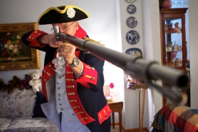
by: Jaime Valdez, Grier dons revolutionary-era garb each Memorial Day, when he appears on behalf of the Lewis and Clark chapter of the Sons of the American Revolution at an annual celebration in Beaverton’s Veterans Memorial Park.
Grier Ingebretsen stands out in a crowd.
Every Memorial Day he does just that at Beaverton American Legion Post 124's annual celebration at Veterans Memorial Park.
Grier is the dashing gentleman wearing the colorful American Revolutionary War uniform.
More than a few heads turn when he takes his place among the sea of people who gather to remember the sacrifices of those who died while serving our country.
The whispers start. Who is that guy? What's his story?
The 69-year-old Multnomah Village resident is a U.S. Navy veteran, who is the descendent of an American Revolution patriot.
How does he know?
His wife Patti Waitman-Ingebretsen told him, of course. Actually, his lovely bride did quite a bit more than just tell him.
She spent countless hours scouring records, tracking the many branches of Grier's family tree and documenting family ties from generation to generation.
DAR membership was the goal
'Grier's mother told me she thought she had a Revolutionary War ancestor,' recalled Patti, a Multnomah Historical Association board member who has been hooked on the study of genealogy for 35 years. 'My goal was to find that person and do the paperwork for her to join the Daughters of the American Revolution.'
Patti, who is a proud member of the organization, was successful in her search and identified what the historical society calls a new patriot on the Ingebretsens' Grier side of the family. (That's right; Grier's first name is an old family name.)
Patti discovered a direct branch to Henry Grier, a lieutenant who served in the artillery at Bunker Hill, opening up a line for his ancestors who settled in Ohio and those who took a wagon train west to the Oregon territory. She also found other ancestors who served in the militia, much like some of her own ancestors.
Patti, who is a member of several historical and genealogical societies across the country, is the descendent of 10 proven patriots, including John Miller of Virginia, who was at Concord's North Bridge in Massachusetts when the first shots were fired, and James and Peter Dicks of North Carolina, who were Quakers who used their home and barn to nurse the wounded from both sides. She is also in the process of identifying links to a few more patriots in her family tree.
Grier and his mother, Evelyn Taylor-Ingebretsen, were delighted by his wife's findings.
'I'm proud of the idea that someone from my family served back then,' he said of his reasons for seeking membership to the Sons of the American Revolution. 'I've always had an interest in history and thought, 'Gee whiz, this is something I could be proud to be involved with.''
Memorial was a popular idea
His involvement with the organization led him to serve as a chapter president and represent the group at veteran celebrations.
It was during one of the American Legion's patriotic programs in Beaverton that Grier came up with an idea.
'I noticed that there was only one round plaque on the main monument that mentioned the American Revolution,' he said. 'I got to thinking about our patriotic ancestors and how we want to honor them.
'We don't want their history to be forgotten.'
Following that Memorial Day program, Grier approached other members of the Lewis and Clark Chapter of the Sons to see what they thought about building a large Revolutionary War monument in the park, which is located between Southwest Washington and Watson avenues in Beaverton.
They were thrilled with the idea, and one of the members drew up plans and created a model for an ambitious memorial that will help educate park visitors about the 13 original colonies, the Declaration of Independence and its signers, the story about Gen. George Washington crossing the Delaware River and the American Creed, as well as offer a historical account of the American Revolutionary War.
'It's a big undertaking,' admitted Grier, who has been working with other members of the local SAR group to garner support for the memorial project. 'It will be the largest Revolutionary War monument this side of the Mississippi.'
'A fabulous teaching tool'
The project has already been embraced by Beaverton American
Legion Post 124 and leaders from both the Tualatin Hills Park and Recreation District and city of Beaverton.
Oregon chapters of the Daughters of the American Revolution are also backing the project with donations.
'I think it's a great project and has the support of the community,' Patti said.
'When it's done, it will be a fabulous teaching tool for the community,' Grier added. 'Teachers could bring their classes to the park, and if they give us enough lead time, we can have our honor guard be here in uniform to answer questions.
'There are a lot of great possibilities.'
But first, they need to raise $240,000 to build the monument.
To find out more information about the American Revolution Memorial Project at Beaverton Memorial Park, visit http://saroregon.org and click on the 'Revolutionary Memorial' tab. Secure, tax-deductible donations to help create the monument can also be made online through the site.
Anyone with questions about the project is also encouraged to walk up to Grier at the next patriotic gathering in Beaverton. He'll be the distinguished fellow in the red, white and blue uniform.
You can't miss him.

